**Team Cross-Over: Project 3 Documentation**

# Team

* Chase Stump
* Marco Borth
* Jack McClure
* Rachel Elting
* Jarod Davis
* Haleigh Hunt

# WORKS CITED

**Battleship was developed in the Unity engine, utilizing provided libraries. Libraries cited:**

* All UI.Buttons, Dropdowns, and UI Panels set to GameObject variables derive from the UnityEngine.UI Library.
* UnityEngine.SceneManagement library was used for the Sceen Manager to reload the game scene.
* UnityEngine library uses the default Start and Update methods created in every

.cs file.

Unity3D.com: Unity Documentation Web Page for Object properties and scripting examples.

* Unity User Manual: ​<https://docs.unity3d.com/Manual/index.htmlls>
* Unity Scripting Reference: ​<https://docs.unity3d.com/ScriptReference/index.html>

Documentation instructions and config files were provided by the official Doxygen website: ​<http://www.doxygen.nl/manual/starting.html>

Imported Assets:

* Simple Health Bar Free:

<https://www.tankandhealerstudio.com/simple-health-bar-free.html>

* Free Download includes Sprites, Scripts, Etc., and an Asteroids Example to demo asset.

# UML

## State Diagram

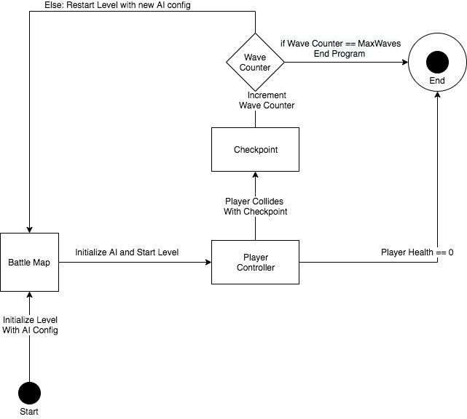

## Use Case Diagram

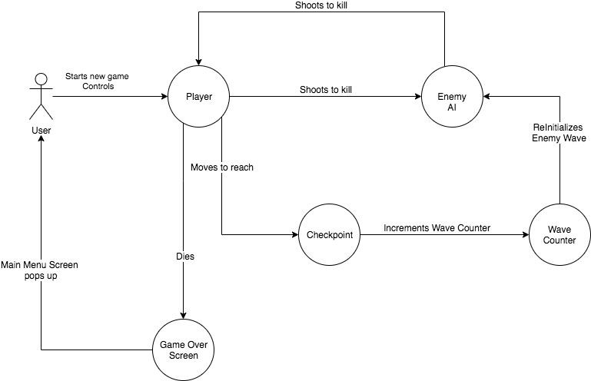

**Class Diagram**

Class diagrams can be found in the Doxygen output for each class. The most notable class diagrams are within the RifleScript and PlayerController classes.

Class Diagram for RifleScript:

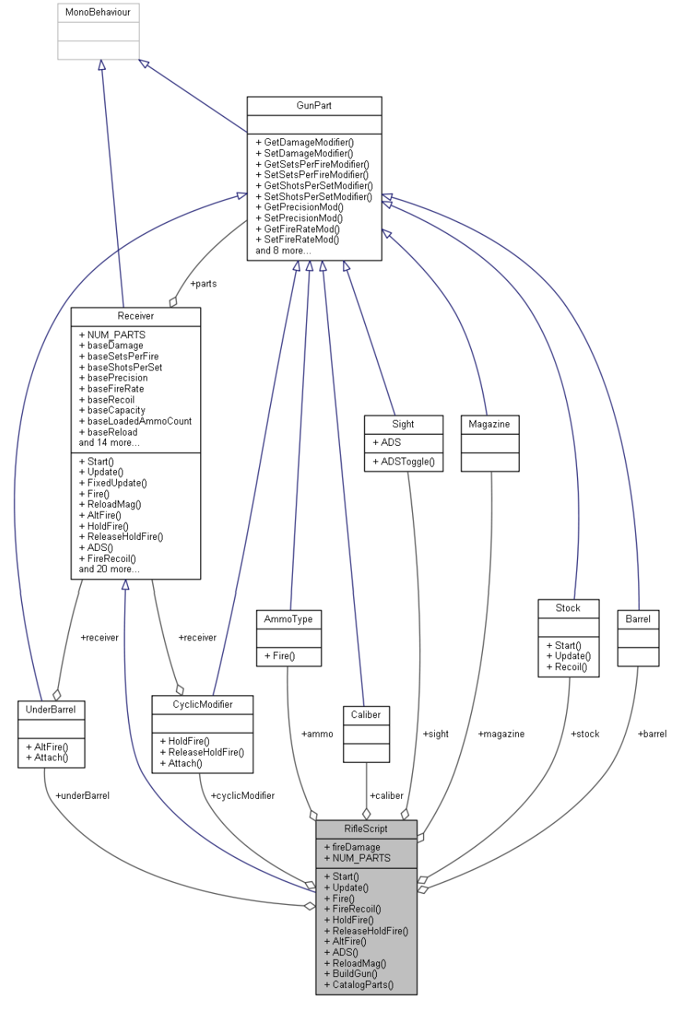

Class Diagram for PlayerController:

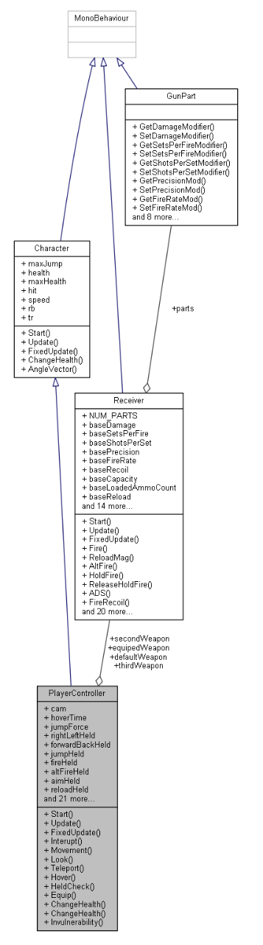

# Scrum

**Product Backlog:**​ an ordered list of the work to be done in order to create, maintain and sustain a product. Managed by the Product Owner.

Character Controller: What it sounds like. Lets us control a character's actions either through automated scripts or user input. Likely will use one abstract class which then will have child classes. For testing though we only need one for the player. I have experience with this and will likely work on this

Weapon System: More or less the weapons will be a collection of parts objects for various things such as stocks. I am the one doing this and will gladly take another hand. For testing all we will attempt to do is produce a gun which then will roll for each of its slots and be usable by the player. Nothing fancy just getting the gun to roll different objects and use the stats from them.

Test Dummies with some form of AI if possible. The AI will be at best some sort of very basic navigation like moving to a fixed location. Maybe have HP that is displayed and can be deducted. Jack will handle AI,

Treasure Chest: Interactable that will spawn 4 "Items" which are randomly rolled. Likely guns from weapon system. Rachel will work on this.

Map: Likely a large room made of 6 boxes, one each for the walls, ceiling and floor. Each will have a collider and not interact with gravity. Jarod and Chase can work on this.

UI: UI will be done by Marco. Ammo counter and health objects drawn on canvas and updating as we change variables. These changes can be done via editor

**Sprint Backlog:** ​an overview of the development work to realize a Sprint’s goal, typically a forecast of functionality and the work needed to deliver that functionality. Managed by the Development Team.

* Preliminary Research: Research needed to be made to plan out core features and core systems for this project.
* Player and Gun Controller: Controllers needed to allow player to move and use gun during gameplay
* BattleMap level Prototype: Prototype Level to demo Project 3 ● Asset Design:

○ Chest Object Design: 3D Object Model design of chest object to use for Lootbox Prototype

* Lootbox Prototype: Prototype of an interactable object for player to interact with.

Will be used to collect items such as health and guns for Player to use.

* Player HUD prototype: Prototype of the Player HUD, including player health bar, aim cursor, and ammo counter.

# Retrospective

**Sprint Meetings:**

## Scrum 1 - 10/23/2019 - Spahr Classroom

Project Ideas:

* Borderlands style shooter
* Galaga

Agreed project:

* Borderlands style shooter

Features:

* Maze/Gauntlet style map with combat rooms and "rest" rooms
* 3D/FPS
* Static maps, NOT random generation.
* No hit scan - projectiles only, requring platforms and upward mobility
* Jump mechanics
* Doom style mechanics
* QWERTY support (input manager)
* Mapping to controller if time allows with (input manager)
* Safe rooms / "rest" rooms for outfitting and equipment
* Weapon generation and customization within the restrooms - heavy customizability with weapons
* General shapes for characters for simplicity - modeling and artwork later.
* Inventory system
* Random enemy spawns
* Player health/shield
* Dumb AI

Stretch goals:

* Multi-player (adversarial & coop) support
* multiple maps
* Multi characters

## Scrum 2 - 10/23/2019 - Spahr Classroom

Plans for week 10/28

-Discussed schedules for the week.

-Nav mesh and all level rooms needs to be completed.

-Hidden Walls that look glitchy

-Trigger colliders and spawning

-Basic AI needs to be set up

-Begin graphic/art and modeling for synthwave bathroom and enemy characters -Animation

## Scrum 3 - 10/30/2019 - Spahr Classroom

-Deciding on enemy character shapes - possibly skeletons. Easier animation. 3D modelling.

-Add physics to dem bones

-Neon horror theme. SPECIAL characters designed by Haleigh -Trigger colliders for rooms still need to be implemented.

-Enemy spawner needed

-Scripts with timers, spawn enemy

-Use flags for rooms

-Modify timers based on areas

-Multiple spawn points for enemies

-Enemies spawning from cracks in the ground - can be hit when facing player, invisible when angled perpendicular -Bullet animations for different ammo

# Challenges

* A New Challenger has joined the team, with Projects 3 and 4 our project would need to ensure that 6 members have a sufficient amount of work split between them for these projects. With the current project as is, our project was able to include more work for new members.
* With only one week to complete this current, our goals for this project had to be scaled down to just developing a working prototype rather than complete a finished project. Prototype should be ready for Demos.

# Features that didn’t make it

● Player HUD layout completed, but more time will be needed for HUD scripting. Will be picked up later in Project 4 under User Interactions.

● While the randomized gun generator is implemented, the random spawning for

the guns is not. The loot crate interaction will be finished in Project 4.

# What we would have done differently

● Clarify with Scrum Master the requirements needed for this project, and if we have met those requirements with the progress made thus far.

# Work Split for Project 3

* **Documentation**​ - Setup completed by Haleigh Hunt and Rachel Elting, all members contributed to documentation
* Refer to Gantt Chart for detailed Work Split for Projects 3 and 4.

**Gantt**

## Timeline

|  |  |  |  |  |  |  |
| --- | --- | --- | --- | --- | --- | --- |
| **dates/team** | **Chase** | **Jack** | **Jarod** | **Haleigh** | **Marco** | **Rachel** |
| **10/25** | **Prelimina ry**  **Research** |  |  |  |  |  |
| **10/26** |  |  |  |  |  |  |
| **10/27** | **Done** |  |  |  |  |  |
| **10/28** | **Player Controlle**  **r** | **AI**  **Prototyp e** | **BattleMa p Level Prototyp e** | **Asset Design** | **Player**  **HUD**  **Prototyp e** | **210**  **Project** |
| **10/29** | **Done** | **Moving**  **AI** |  | **Chest**  **Object**  **Design** |  | **210**  **Project** |
| **10/30** | **Gun**  **Controlle**  **r** | **Moving**  **AI** |  | **Chest**  **Object**  **Design**​**<-**  **Done** |  | **563**  **Project** |
| **10/31** | **Done** | **Moving**  **AI** |  |  |  | **563**  **Project** |
| **11/1** |  | **Moving**  **AI**​**<-**  **Done** | **Done** |  | **Done** | **Lootbox Prototyp e** |
| **11/2** |  |  | **Project Finalizati on** |  |  | **Lootbox Prototyp e** |
| **11/3** |  |  |  |  |  | **Lootbox** |

|  |  |  |  |  |  |  |
| --- | --- | --- | --- | --- | --- | --- |
|  |  |  |  |  |  | **Prototyp**  **e**  **Doxygen Documen**  **tation** |
| **11/4** | **368 Projects/ Labs 5 and 6/ Project 3 Demo** | | | | |  |
| **11/5** |
| **11/6** |
| **11/7** |
| **11/8** |
| **11/9** | **Weapons System** | **AI Design** | **Level Design** | **Characte r Design** | **User Interactio ns** | **Level Design** |
| **11/10** |  | **AI Firing** | **Level**  **Design,**  **Textures** | **Player**  **Model**  **Design**  **Textures** | **Player**  **HUD**  **Scripting** | **Level**  **Design,**  **Textures** |
| **11/11** |  | **AI Firing** | **Level**  **Design,**  **Textures** | **Player**  **Model**  **Design**  **Textures** | **Player**  **HUD**  **Scripting** | **Level**  **Design,**  **Textures** |
| **11/12** |  | **AI Firing** | **Level**  **Design,**  **Textures** | **Player**  **Model**  **Design**  **Textures** | **Player**  **HUD**  **Scripting** | **Level**  **Design,**  **Textures** |
| **11/13** |  | **AI**  **Variants:**  **Turrets, Melee, etc.** | **Level**  **Design,**  **Textures** | **Enemy AI**  **Model**  **Design**  **Textures** | **Pause Menu** | **Level**  **Design,**  **Textures** |
| **11/14** |  | |  |  | | --- | --- | | **AI** |  | | **Variants** | | | **Level**  **Design,**  **Textures** | **Enemy AI**  **Model**  **Design**  **Textures** | **Pause Menu** | **Level**  **Design,**  **Textures** |
| **11/15** |  | **AI** | **Level** | **Enemy AI** | **Pause** | **Level** |

|  |  |  |  |  |  |  |
| --- | --- | --- | --- | --- | --- | --- |
|  |  | **Variants** | **Design, Textures** | **Model**  **Design**  **Textures** | **Menu** | **Design, Textures** |
| **11/16** | **Project Midpoint** | | | | | |
| **11/17** |
| **11/18** | **510**  **Midterm** | **AI Wave Configur ations** | **510 Midterm** | | | **563**  **Project** |
| **11/19** | **AI Wave Configur ations** |
| **11/20** | **AI Wave Configur ations** |
| **11/21** | **AI Wave Configur ations** |
| **11/22** | **Weapons System** | **AI Wave Configur ations** | **Textures** | **Characte r Design** | **User Interactio ns** | **Textures** |
| **11/23** |  | **AI Wave Configur ations** | **645**  **Midterm** | **Enemy AI**  **Model**  **Design**  **Textures** | **645**  **Midterm** | **Textures** |
| **11/24** |  | **AI Wave Configur ations** | **Enemy AI**  **Model**  **Design**  **Textures** | **Textures** |
| **11/25** |  | **AI Wave Configur ations** | **Enemy AI**  **Model**  **Design**  **Textures** | **Textures** |
| **11/26** |  | **AI Wave Configur ations** | **Textures** | **Enemy AI**  **Model**  **Design** | **User Interactio ns** | **Textures** |
|  |  |  |  | **Textures** |  |  |
| **11/27** | **Happy Thanksgiving** | | | |  | |
| **11/28** |
| **11/29** |
| **11/30** |  |  | **Project Finalizati on** |  |  |  |
| **12/1** |  |  |  |  |  | **Doxygen Documen**  **tation** |